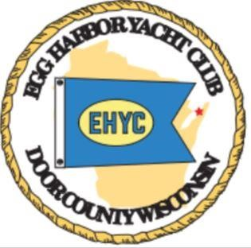
EGG HARBOR YACHT CLUB

ANNUAL
MEMBERSHIP AND RENEWAL FORM

LAST NAME | FIRST NAME |  |  | NAME OF SPOUSE/PARTNER
STREET ADDRESS |  |  | CITY, STATE |  | ZIP CODE
PRIMARY PHONE |  | ADDITONAL PHONES (S) |  | BOAT NAME
EMAIL ADDRESS(ES) WHERE YOU WOULD LIKE NOTIFICATIONS OF UPCOMING ACTIVITIES AND EVENTS SENT. You may include more than one
Dues are $45/year
Please complete form and send with your check made payable to:
Egg Harbor Yacht Club, Inc.
PO Box 110
Egg Harbor, WI 54209

Upon receipt of your payment, you will be sent a membership card and the current year’s password for the ‘Member’s Only’ page on our website. The EHYC annual membership runs from January 1st through December 31st each year.
Thank you for joining or renewing your membership
Welcome Aboard!

